**SECURE-BANKING APPLICATION**

**Software Requirement Specification (SRS) Document**

**Sprint 1 Implementation**

**Project Timeline:05-12-2022 to 12-12-2022**

**SOFTWARE REQUIREMENT SPECIFICATIONS**

***Project Name:*** *Secure Banking*

***Document Title:*** *SRS*

***Project Type:*** *File Handling in C*

***Project Timeline:*** *05.12.2022 to 12.12.2022*

**INDEX**

**1. Introduction**

1.1 Purpose

1.2 Intended audience

1.3 Intended use

1.4 Scope

**2. Overall Description**

2.1 Assumptions and Dependency

**3. System feature and requirements**

**3.1 Functionality**

3.1.1 SBA_01->Account creation

3.1.2 SBA_02-> Login

3.1.3 SBA_03->Check Balance

3.1.4 SBA_04->Display

3.1.5 SBA_05-> Logout

**3.2 System requirement**

3.2.1 Software requirements

3.2.2 Hardware requirements

3.3 System features

**4. Data Flow Diagrams**

4.1 DFD level 0

4.2 DFD level 1

**5.Appendix**

**1.Introduction**

The introduction of the software requirement specification provides an overview of the entire software. The entire SRS with overview description purpose, scope, tools used and basic description.

The aim of this document is to gather, analyse and give an in-depth insight into the Secure Banking application by defining the problem statement in detail.

The detailed requirements of the Secure Banking Application is provided in this document.

* 1. **Purpose:**

The purpose of this document is to show the requirements for the Secure banking application which creates a direct contact between the customers and the bank interface without the involvement of mediators.

* 1. **Intended Audience:**

This document is intended to be read by, Client.

* 1. **Intended Use:**
* Development Team
* Maintenance Team
* Clients

Since this is a general-Purpose software anyone can access it.

* 1. **Scope:**

This project aims to create the development of secure banking application. This system consists of an application which will serve as a platform for customers to do transactions from the secure banking application.

**2.Overall Description**

Nowadays, banking system has been more accessible than ever to perform essential duties e.g online transfer, change account information without having the need to visit nearby bank and perform all of them through online. While the online access to banking functionality for users has given great flexibility but it requires sufficient security provided by the banking company to help protect from unauthorised access to the user’s account and help the users to perform his activity securely maintaining the privacy.

The secure Online Banking System is a web application, compatible with any web browser with access to internet, providing online banking services for the customers of the bank and ensures security, integrity and confidentiality of customer’s activity and personal information from unauthorised access. The system provides the bank process of all the customer transactions and requests.

* 1. **Assumptions and Dependency:**
* System should have any flavour of Linux installed.
* System should have either 4GB or more RAM.
* The service is used preferably on a desktop or laptop.

**3. System Features and Requirements**

**3.1 Functionality:**

**3.1.1: SBA_01->Account Creation:**

If a customer wants to create a new account first they have to register with twelve digits Aadhar number and personal details like name and phone number after giving the details of OTP will sent to the mobile number in the form of sms.

**3.1.2: SBA_02-> Login:**

If the user is valid, then the user should login by giving their login id and password. If the login id and password is correct then the customer have a chance to further next.

**3.1.3: SBA_03-> Check Balance:**

if the user want to credit or debit the amount they have a choice to check the balance. If the balance limit is satisfied the user can access services.

**3.1.4: SBA_04-> Display:**

After choosing the user validation it displays the user details that user wants to enter.

**3.1.4: SBA_05-> Logout**:

After accessing all the services, the user can logout from the application.

**3.2 System Requirements:**

**3.2.1: Software Requirements:**

* + - * Operating System -Windows 11
      * Server-side script - C Language
      * IDE - Putty
      * Libraries used - C libraries

**3.2.2: Hardware Requirements:**

* Processor - i5/Intel Processor
* RAM - 4GB (min)
* Hard Disk - 128 GB
* Keyboard - Standard Keyboard
* Mouse - Two or three button mouse
* Monitor - Any

**3.2.3: Tools to be used:**

* Valgrind
* Splint
* C File Handling
* Make multiple files

**3.3 System Features:**

* **Supportability:** The system is easy to use.
* **Design Constraint:** The system is built using only C language.
* **Usability:** The Secure banking application is used to do the transactions by using this online application without going to the banks.
* **Reliability & Availability:** The application is available 24/7 that is whenever the customer would like to use the application. The customer simply login it.
* **Performance:** The system will work on the user’s terminal.

**4. Data Flow Diagrams**

**4.1 DFD Level 0:**

**4.2: DFD Level 1:**

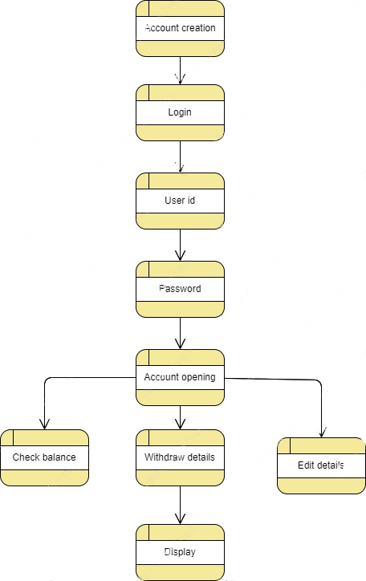

**6.Appendix**

* <https://www.geeksforgeeks.org/bank-account-system-in-c-using-file-handling>
* <https://coderspacket.com/simple-c-program-for-banking-system>